**Results**

**2T-test results**

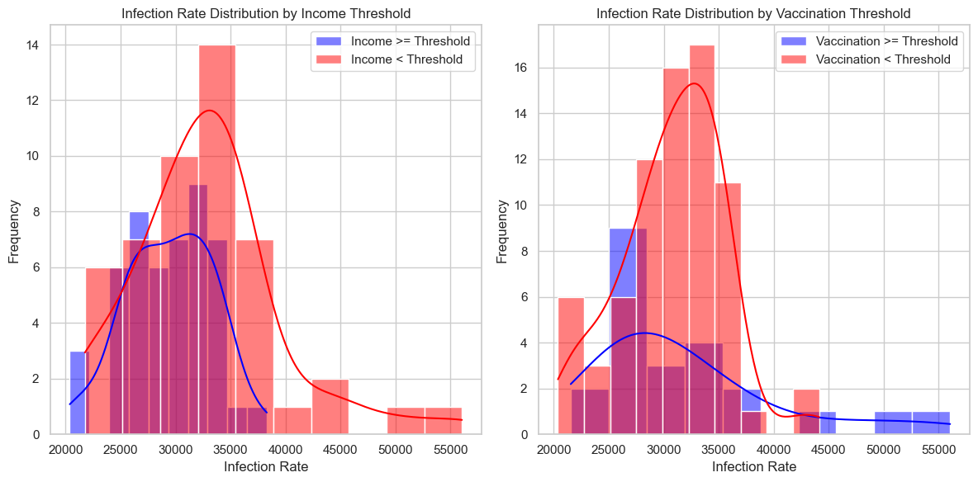

**T-Test Results for Income Thresholds:**

T-Statistic: -2.9718415514397916

-This t-statistic measures the difference in the means of infection rates between counties with median household income above the threshold and those below the threshold.

-A negative t-statistic suggests that counties with higher incomes have, on average, lower infection rates.

P-Value: 0.003749941062923792

-The p-value represents the probability of observing such a difference in means by random chance.

-In this case, the p-value is less than 0.05, indicating that the difference in means is statistically significant at a 5% significance level. Therefore, income appears to have a significant effect on infection rates.

**T-Test Results for Vaccination Thresholds:**

T-Statistic: 0.8375038137576495

-This t-statistic measures the difference in the means of infection rates between counties with a percentage of the population vaccinated above the threshold and those below the threshold.

-The positive t-statistic suggests that there is a slight difference in means, but it is not as pronounced as in the income threshold test.

P-Value: 0.4044114709769113

-The p-value for this test is greater than 0.05, indicating that the difference in means is not statistically significant at a 5% significance level. This suggests that vaccination rates may not have a significant effect on infection rates.